Circuits and Control Coursework

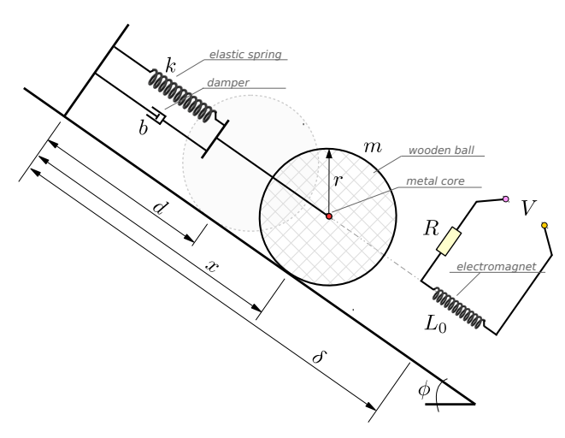
Counter-clockwise rotations are positive

Variables
d = natural length of the spring
x = Distance b/w the centre of the ball and the wall
δ = Distance b/w the centre of the electromagnet and the wall
y = distance b/w the centre of the ball and the centre of the electromagnet
k = elastic spring of stiffness
b = viscous damping coefficient
m = mass of the ball
g = acceleration due to gravity
r = radius of the ball
R = Resistance
V = Applied voltage
L₀ = nominal inductance
L₁ = positive constants
α = positive constants
c = positive constant
I = The current that runs through the circuit
φ = angle of incline

Forces

Force from spring
F_{spring} = ke_{x}
e_{x} = x – d
F_{spring} = k(x - d)
Where:
- k = elastic spring of stiffness
- e_{x} = extension
- x = Distance b/w the centre of the ball and the wall
- d = natural length of the spring

Force from damper
F_{damper} = b$\dot{x}$
Where:
- b = Viscous damping coefficient
- $\dot{x}$ = Velocity of the ball

Weight of ball
N = mgcosφ = 0
F_{ball} = mgsinφ
Where:
- N = Reaction
- m = mass
- g = acceleration due to gravity
- φ = angle of incline
- I = Moment of inertia
- r = radius of the ball
- T = Torque of the ball that causes rotation

Torque of Ball (Force that causes rotation
I = $\frac{2}{5}$mr²
F_{Torque} = $\frac{I\ddot{φ}}{r}$
F_{Torque} = $\frac{2}{5}$mr² x $\frac{\ddot{φ}}{r}$
F_{Torque} = $\frac{2mr^{2}\ddot{φ}}{5r}$
F_{Torque} = $\frac{2mr\ddot{φ}}{5}$
F_{Torque} = $\frac{2m\ddot{x}}{5}$
Where:
- I = Moment of inertia
- m = mass
- r = radius of the ball

Force from electromagnet
V = L$\dot{I}$ + IR
$\dot{I}$ = $\frac{V}{L}$ - $\frac{IR}{L}$
$\dot{I}$ = $\frac{1}{L}$(V - IR)
I = $\frac{V - \dot{IL}}{R}$
L = L₀ + L₁ exp(−αy)
F_{mag} = c $\frac{I^{2}}{y^{2}}$
y = δ - x
Where:
- L = Inductance
- L₀ = nominal inductance
- L₁ = Positive constants
- α = Positive constant
- y = Distance b/w the centre of the ball and the centre of the electromagnet
- c = Positive constant
- I = Current
- δ = Distance b/w the centre of the electromagnet and the wall
- x = Distance b/w the centre of the ball and the wall

Total Force
F_{tot} = - F_{spring} - F_{damper} - F_{Torque} + F_{Weight} + F_{mag}
m$\ddot{x}$ = -k(x - d) - b$\dot{x}$ + $\frac{2mr\ddot{φ}}{5}$ + mgsinφ + c $\frac{I^{2}}{y^{2}}$

$\ddot{x}$ = $r\ddot{φ}$
m$\dot{x_{2}}$ = -k(x₁ – d) - bx₂ + $\frac{2mr\ddot{φ}}{5}$ + mgsinφ + c $\frac{I^{2}}{y^{2}}$
m$\dot{x_{2}}$ = -k(x₁ – d) - bx₂ + $\frac{2m\ddot{x}}{5}$ + mgsinφ + c $\frac{I^{2}}{y^{2}}$
m$\dot{x_{2}}$ - $\frac{2m\dot{x_{2}}}{5}$ = -k(x₁ – d) - bx₂ + mgsinφ + c $\frac{I^{2}}{y^{2}}$
$\frac{(5m- 2m)\dot{x_{2}}}{5}$ = -k(x₁ – d) - bx₂ + mgsinφ + c $\frac{I^{2}}{y^{2}}$
$\frac{3m\dot{x_{2}}}{5}$ = -k(x₁ – d) - bx₂ + mgsinφ + c $\frac{I^{2}}{y^{2}}$

$\dot{x_{2}}$ = $\frac{5}{3m}$(-k(x₁ – d) - bx₂ + mgsinφ + c$\frac{I^{2}}{y^{2}}$)

State Space Representation
x = [ $\begin{matrix}x_{1} \\ x_{2} \\ I\end{matrix}$ ] | $\dot{x}$ = [ $\begin{matrix}x_{2} \\ \frac{5}{3m} (-k\left(x_{1} – d\right)-bx_{2}+ mgsinφ+ c \frac{I^{2}}{{(δ - x_{1})}^{2}}) \\ \frac{1}{L_{O} + L_{1} e^{-αy}}(V - IR)\end{matrix}$ ]

Characterise the Equilibrium Points of the System Using Proposition
The input of the system is the voltage across the circuit and the output is the position of the ball on the inclined plane.

x₂e = 0
$\frac{5}{3m} (-k\left(x_{1}^{e} – d\right)-bx_{2}^{e}+ mgsinφ+ c \frac{{(I^{e})}^{2}}{{\left(δ - x_{1}^{e}\right)}^{2}}$ = 0
$\frac{1}{L_{O} + L_{1} e^{-αy}}\left(V^{e} - I^{e}R\right)$ = 0

Linearise the System at an Equilibrium Point (Use Deviation Variables)
 | $\dot{x}$ =$x_{2}$
- | 0 = x₂e
 | $\dot{x}$ = $x_{2}$ - x₂e  $\dot{\overline{x}}$ = $\overline{x_{2}}$ | $\overline{x_{2}}$ = $x_{2}$ - x₂e

 | $\dot{x}$ =$\frac{5}{3m} (-k\left(x_{1} – d\right)-bx_{2}+ mgsinφ+ c \frac{I^{2}}{{(δ - x_{1})}^{2}}$ )
- | 0 = $\frac{5}{3m} (-k\left(x_{1}^{e} – d\right)-bx_{2}^{e}+ mgsinφ+ c \frac{{I^{e}}^{2}}{{\left(δ - x_{1}^{e}\right)}^{2}}$ )
 | $\dot{x}$ = $\frac{5}{3m} (-k(x_{1}- x_{1}^{e})$ - $b(x_{2}- x_{2}^{e} )$) +$c \frac{I^{2}}{{(δ - x_{1})}^{2}}$ - $c \frac{{I^{e}}^{2}}{{\left(δ - x_{1}^{e}\right)}^{2}}$ )  $\dot{\overline{x}}$ = $\frac{5}{3m} (-k\overline{x_{1}}$ - b$\overline{x_{2}}$ +$c \frac{I^{2}}{{(δ - x_{1})}^{2}}$ - $c \frac{{I^{e}}^{2}}{{\left(δ - x_{1}^{e}\right)}^{2}}$) | $\overline{x_{2}}$ = $x_{2}$ - x₂e

 | $\dot{I}$ = $\frac{1}{L_{O} + L_{1} e^{-αy}}$(V - IR)
- | 0 = $\frac{1}{L_{O} + L_{1} e^{-αy}}$(Ve - $I^{e}$R)
 | $\dot{I}$ = $\frac{1}{L_{O} + L_{1} e^{-αy}}$ ($V -{ V}^{e}$ - (I - $I^{e}$)R)  $\dot{\overline{I}}$ = $\frac{1}{L_{O} + L_{1} e^{-αy}}$ ($\overline{V}$ - $\overline{I}$R) | $\overline{V}$ = V - Ve

